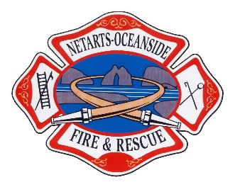
NETARTS-OCEANSIDE RURAL FIRE
PROTECTION DISTRICT
October 10th, 2023 – Board of Directors Meeting Agenda

Date: Tuesday October 10th, 2023
Time: 18:00
Location: Netarts Fire Hall

BOARD MEMBERS: DISTRICT ADMINISTRATION:
Erin Rieger (Position 1, 2023 – Vice President) Tim Carpenter (Fire Chief)
Steve Roan (Position 2, 2023 – Secretary/ Treasurer) Shawna Yost
Brent Collier (Position 3, 2025 – Director) VOLUNTEERS:
Scott Campbell (Position 4, 2025 – President) ____________________________________
Bruce Lovelin (Position 5, 2023 – Director) OTHERS:
____________________________________

Call to Order and Roll Call

- Prothman Presentation via zoom

Communications:

Executive Session:

Resolutions:

Consent Agenda:
- Minutes – 9/12/2023 Board Meeting
- Finance Reports – See board packet.
- Fire Chief’s Report –
- Board Member’s Report –
- Volunteer Association Report –
- Safety Report –

Unfinished business:
- 1275 5th Street Loop

New Business:
- OSFM Grant Report
- Oregon Fire Service Conference: Seaside, November 2nd, 3rd, & 4th
- Conflagration Policy
- Fire Chief job description

Committee Reports:

Pending Agenda Items:

Training/Conferences/Seminars:

Next Board Meeting: November 14th, 2023, 18:00 at Netarts Fire Hall

