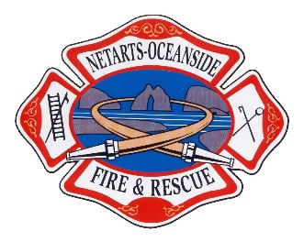
NETARTS-OCEANSIDE RURAL FIRE
PROTECTION DISTRICT
April 9th, 2024 – Board of Directors Meeting Agenda

Date: Tuesday April 9th, 2024
Time: 18:00
Location: Netarts Fire Hall:

BOARD MEMBERS DISTRICT ADMINISTRATION
Erin Rieger (Position 1, 2027 – Vice President) Tim Carpenter (Fire Chief)
Steve Roan (Position 2, 2027 – Secretary/ Treasurer) Shawna Yost
Brent Collier (Position 3, 2025 – Director) OTHERS IN ATTENDANCE
Scott Campbell (Position 4, 2025 – President) __________________________________
Bruce Lovelin (Position 5, 2027 – Director) __________________________________
__________________________________

Call to Order and Roll Call

Communications:

Executive Session:
- ORS 192.660(2)(a), Employment of Public Officers, Employees, and Agents – Fire Chief Contract Review

Resolutions:

Consent Agenda:
- Minutes –
- Finance Reports –
- Fire Chief’s Report –
- Board Member’s Report –
- Volunteer Association Report –
- Safety Report –

Old/Unfinished business:
- Policy review and adoption

New Business:

Committee Reports:

Pending Agenda Items:

Training/Conferences/Seminars:

Next Board Meeting: Tuesday, May 14th, 2024 - 18:00 at Netarts Fire Hall

Draft Budget Available Last Week of April

1st Budget Meeting: Tuesday, May 7th – 17:30 at Netarts Fire Hall

