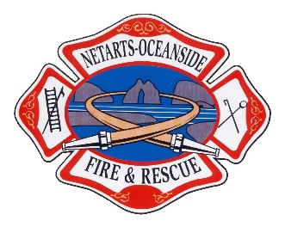
NETARTS-OCEANSIDE RURAL FIRE
PROTECTION DISTRICT
November 14th, 2023 – Board of Directors Meeting Agenda

Date: Tuesday November 14th, 2023
Time: 18:00
Location: Netarts Fire Hall

BOARD MEMBERS: DISTRICT ADMINISTRATION:
Erin Rieger (Position 1, 2023 – Vice President) Tim Carpenter (Fire Chief)
Steve Roan (Position 2, 2023 – Secretary/ Treasurer) Shawna Yost
Brent Collier (Position 3, 2025 – Director) VOLUNTEERS:
Scott Campbell (Position 4, 2025 – President) ____________________________________
Bruce Lovelin (Position 5, 2023 – Director) OTHERS:
____________________________________
Call to Order and Roll Call

Communications:
- Municipal Audit Law Changes

Executive Session:

Resolutions:
- Sale of Surplus – Diesel powered Generator

Consent Agenda:
- Minutes – 10/10/2023 Board Meeting
- Finance Reports – See board packet.
- Fire Chief’s Report –
- Board Member’s Report –
- Volunteer Association Report –
- Safety Report –

Old/Unfinished business:
- 1275 5th Street Loop
- Ford Motor
- OSFM Seasonal Staffing Grant
- Oregon Fire Service Conference

New Business:
- Fire Chief job description
- Consulting services
- Cyber Security Coverage

Committee Reports:

Pending Agenda Items:
- Long Range Planning

Training/Conferences/Seminars:
- SDAO Conference – Seaside - February 8-11th

Next Board Meeting: December 12th, 2023, 18:00 at Netarts Fire Hall

